

Schools must use the funding to make additional and sustainable improvements to the quality of PE and sport they offer. This means that you should use the Primary PE and Sport Premium to:

- develop or add to the PE and sport activities that your school already offers
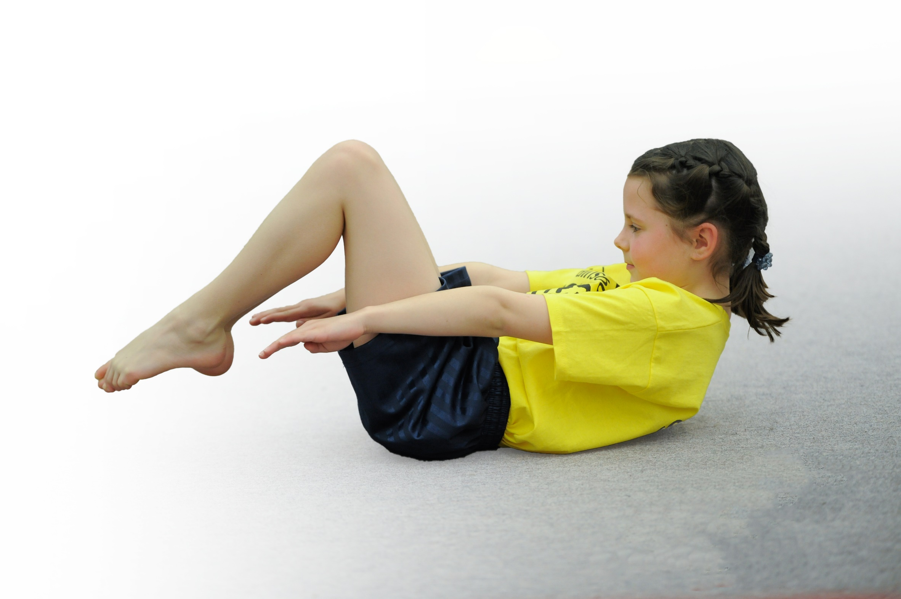
- build capacity and capability within the school to ensure that improvements made now will benefit pupils joining the school in future years

Please visit gov.uk for the revised DfE guidance including the 5 key indicators across which schools should demonstrate an improvement. This document will help you to review your provision and to report your spend. DfE encourages schools to use this template as an effective way of meeting the reporting requirements of the Primary PE and Sport Premium.

We recommend you start by reflecting on the impact of current provision and reviewing the previous spend.
Under the Ofsted Schools Inspection Framework, inspectors will assess how effectively leaders use
the Primary PE and Sport Premium and measure its impact on outcomes for pupils, and how effectively governors hold them to account
for this.

Schools are required to publish details of how they spend this funding as well as on the impact it has on pupils’ PE
and sport participation and attainment.
We recommend regularly updating the table and
publishing it on your website as evidence
of your ongoing review into how you are using the money
to secure maximum, sustainable impact. To see an example of how to complete the table please click HERE.

Support for review and reflection - considering the 5 key indicators from DfE, what development needs are a priority for your setting and your students now and why? Use the space below to reflect on previous spend, identify current need and priorities for the future.

Key achievements to date: | Areas for further improvement and baseline evidence of need:
- Introduction of new planning and assessment tool. Giving staff confidence to deliver a range of different activities.  - Staff Meeting was a success and teachers commented that increasing levels was both important and achievable.  - Range of activities available to children after-school through clubs and competitions. | - Allow time to develop staff confidence by delivering in house CPD sessions using PE specialist teachers and TA's. 6 weeks, 2 observations, 2 team teach, 2 observations.  - Improve regularity of PE Kit.  - Time for PE subject lead to deliver CPD for staff, including extra training to use new planning and assessment tool.  - More inter school competitions, build links with local schools to provide another level of competition for all children.

Meeting national curriculum requirements for swimming and water safety | Please complete all of the below*:
What percentage of your current Year 6 cohort swim competently, confidently and proficiently over a distance of at least 25 metres? | 88%
What percentage of your current Year 6 cohort use a range of strokes effectively [for example, front crawl, backstroke and breaststroke]? | 88%
What percentage of your current Year 6 cohort perform safe self-rescue in different water-based situations? | 88%
Schools can choose to use the Primary PE and Sport Premium to provide additional provision for swimming but this must be for activity over and above the national curriculum requirements. Have you used it in this way? | No
*Schools may wish to provide this information in April, just before the publication deadline.

Action Plan and Budget Tracking
Capture your intended annual spend against the 5 key indicators. Clarify the success criteria and evidence of impact that you intend to measure to evaluate for students today and for the future.

Academic Year: 2017/18 | Total fund allocated: £10,650 | Date Updated: 28/03/18
Key indicator 1: The engagement of all pupils in regular physical activity – Chief Medical Officer guidelines recommend that primary school children undertake at least 30 minutes of physical activity a day in school |  |  |  | Percentage of total allocation:
 |  |  |  | %
School focus with clarity on intended impact on pupils: | Actions to achieve: | Funding allocated: | Evidence and impact: | Sustainability and suggested next steps:
Continuation / extension of established successful programme of change for life, breakfast, lunchtime and after school activities. With the addition of more physical activity within lessons and during school. | Continue to fund current provision with the addition of a Wed (staff meeting) ASC to be run by Manchester City. Update displays especially curriculum ones, continue celebration assemblies, links to healthy eating, change for life and cross curricular work etc (Forest School)  School will continue to provide coaches, to deliver breakfast, lunchtime and after-school clubs  Delivery of parent and child fitness sessions before school each day. | £4000 (PSC)  £500 (Manchester City) | Children fully engaged at lunchtimes in a range of activities.  Numbers from ASC registers. | - continue to provide staff training and encourage to take on ASC
Key indicator 2: The profile of PE and sport being raised across the school as a tool for whole school improvement |  |  |  | Percentage of total allocation:
 |  |  |  | %
School focus with clarity on intended impact on pupils: | Actions to achieve: | Funding allocated: | Evidence and impact: | Sustainability and suggested next steps:
Using PE as a vehicle to be at the heart of British Values, supporting the whole school ethos. Whole school approach to PE & Swimming, and engagement in Physical Activity. | Sports Leaders (Crew) new leaders to be trained to support intra school sports comps / lunchtimes/Before School. The Olympic and Paralympic Value displays update across the school to support the schools work on British Values. Sports leaders to develop in school competitions and assist with the delivery of sports day and fitness club.  All certificates for sporting achievements to be handed out during celebration assemblies.  Sportsman/woman of the year to be nominated and awarded to the outgoing year 6 children.  Display all competition events on sports notice board and regularly update the sports blog and begin to use a school sport twitter. | £600 (MOTD)  £700 (PE Kit)  £320 (Trophies) | Increased engagement and attainment in Maths.  Number of children regularly wearing appropriate PE kit. | Introduction of Active Literacy with the support of the Literacy team.

Key indicator 3: Increased confidence, knowledge and skills of all staff in teaching PE and sport |  |  |  | Percentage of total allocation:
 |  |  |  | %
School focus with clarity on intended  impact on pupils: | Actions to achieve: | Funding  allocated: | Evidence and impact: | Sustainability and suggested  next steps:
Continue to support staff confidence, competence and subject knowledge through CPD and improved access to resources. | Re-new license for PE Passport planning and assessment tool.  Continue to audit and replenish PE equipment, using the sports leaders and staff to identify need for new equipment.  Deliver PE Meeting with whole school staff.  PE Lead to attend meetings throughout the year to keep staff updated on PESSP | £500 (PE Passport)  £700 (Equipment)  £3000 (Manchester City) | License for PE Passport has been renewed. This allows teachers in all years to have access to a range of planning that link directly from the curriculum and aims to improve children's physical literacy from EYFS to Year 6.  Manchester City have been employed to deliver 1 day a week in EYFS/KS1/KS2.  NQT's have attended PE CPD courses.  PE Meeting delivered to introduce importance of PE & Physical activity, along with MOTD Demonstration. | Extend knowledge and understanding by continuing to train staff using the App. Subject leader to have time to team teach and observe. Teachers will also benefit from observing in MCFC sessions.
Key indicator 4: Broader experience of a range of sports and activities offered to all pupils |  |  |  | Percentage of total allocation:
 |  |  |  | %
School focus with clarity on intended  impact on pupils: | Actions to achieve: | Funding  allocated: | Evidence and impact: | Sustainability and suggested  next steps:
Continue the successful programme of extra-curricular activities and develop for specific groups (SEND/G&T). | Girls fitness sessions:  School to continue to fund a wide range of coaches and specialist coaches to inspire all groups of pupils G &T, motor skills, EAL, SEN.  Northern Tennis delivered afterschool sessions. Money raised to be re-invested into school sport funds. | £300 (Thai Boxing Club) | A Thai Boxing club set up to access previously inactive children.  SEN children participated in inclusion festivals.  Fitness sessions introduced before school. Girls specific run during the day by PE TA’s | Continue to advertise and promote a range of extra-curricular activities using pupil voice and School Games Calendar to tailor our offer.
Key indicator 5: Increased participation in competitive sport |  |  |  | Percentage of total allocation:
 |  |  |  | %
School focus with clarity on intended  impact on pupils: | Actions to achieve: | Funding  allocated: | Evidence and impact: | Sustainability and suggested  next steps:
Continue to engage / expand fully with School Games competitions and develop intra school competitions. Promote local clubs allowing pathways for all children. | Coaches / teachers to continue to support delivery of intra-school sports competitions and training sports leaders to support. Host some fixtures including local schools.  School will continue to use the school budget to pay for additional hours to attend competitions, the running of the school mini bus, coaches to support G & T practices and purchasing of equipment needed for competitions including inclusion activities.  Use of PE subject Leaders and school games crew time to guide G & T activities. |  | Award of School Games Award  Links with local rugby league club Mancunians have been made. Including accessing their school competitions throughout the year. | More inter-school events between local schools. Development of a cluster who can meet all year to develop competitions.  Let children know about their local clubs as part of a display.

