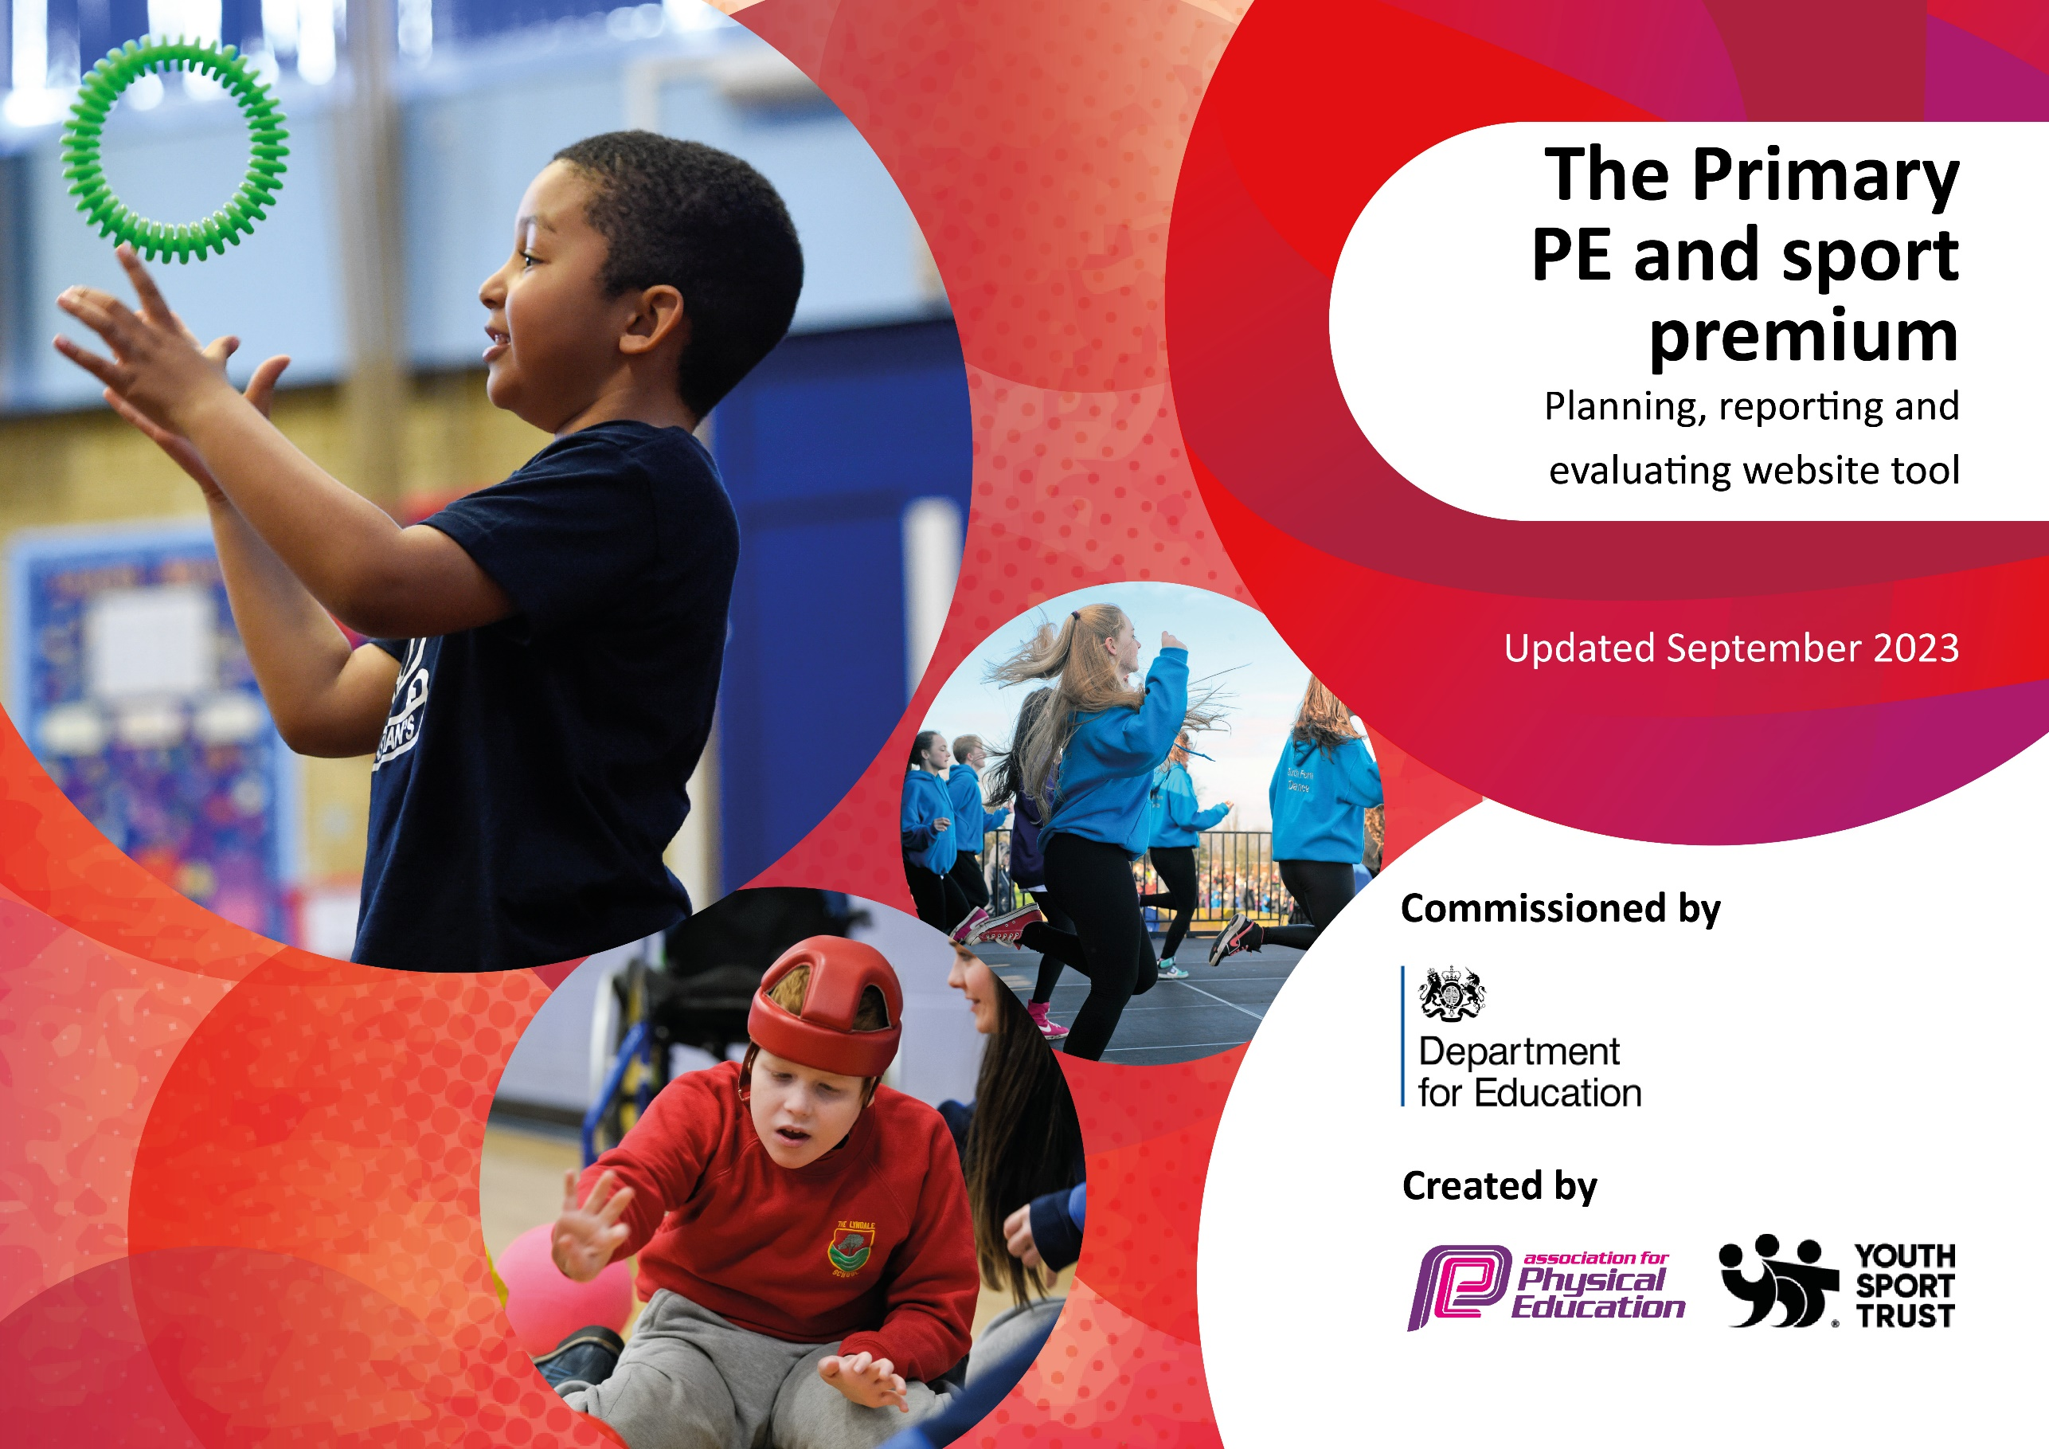

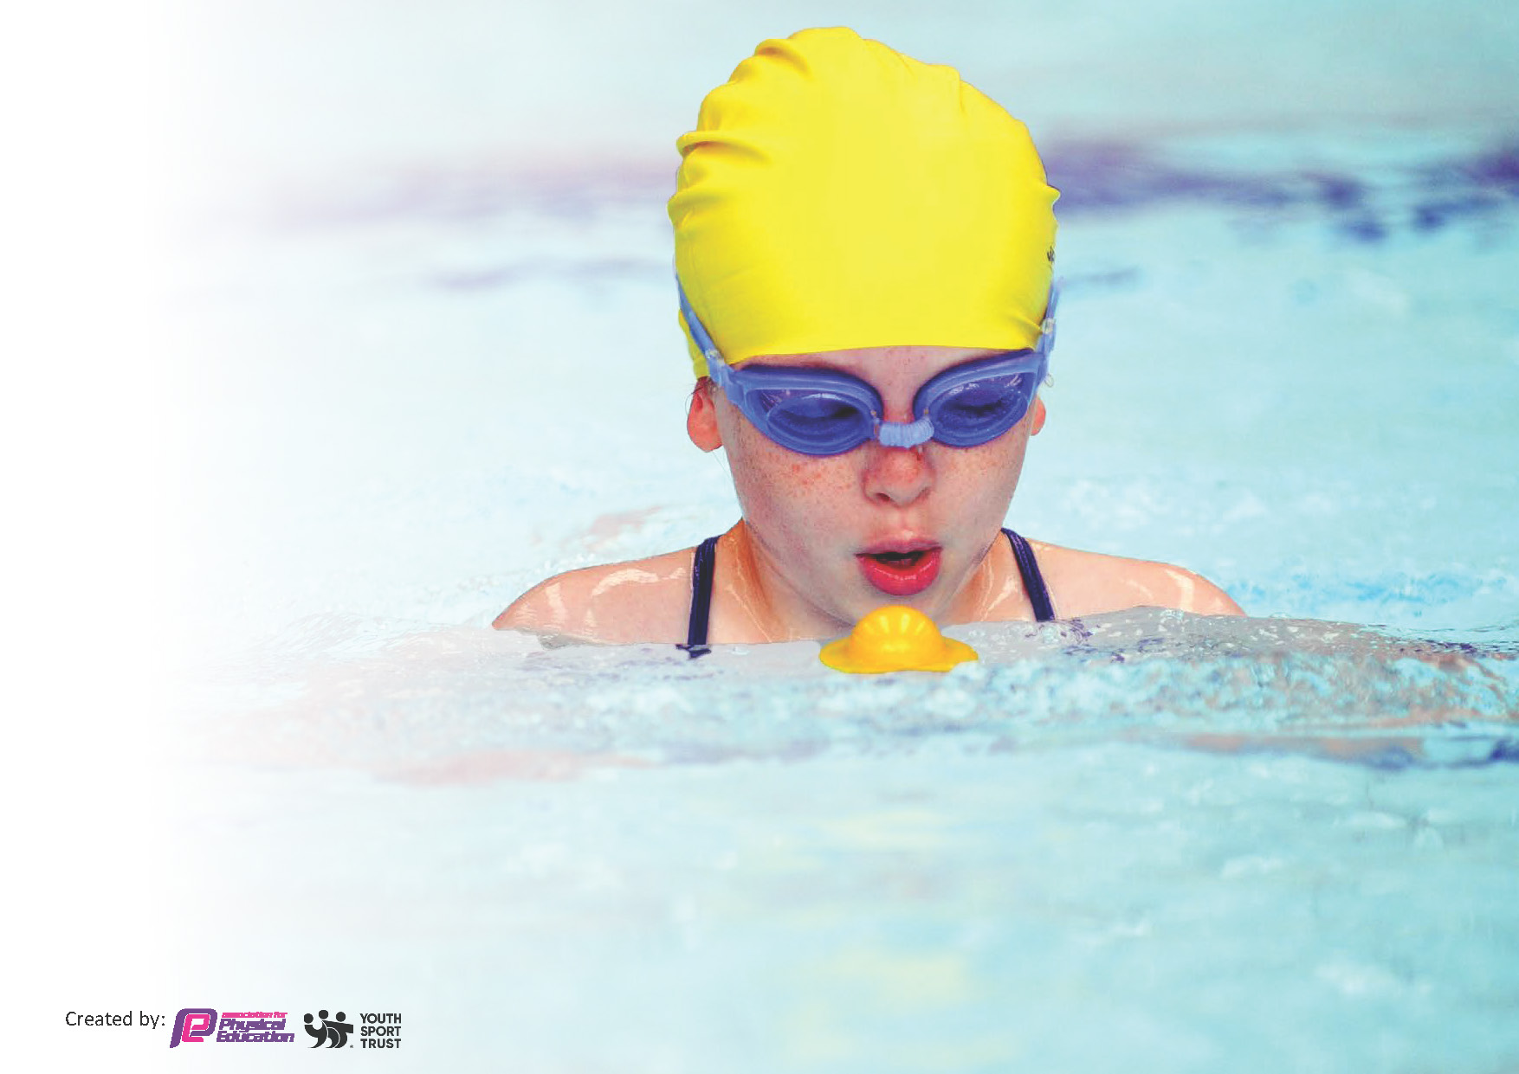
This template can be used for multiple purposes:
by:
- It enables schools to effectively plan their use of the Primary PE and sport premium
- It helps schools to meet the requirements (as set out in guidance) to publish information on their Primary PE and sport premium
- It will be an effective document to support Ofsted inspections enabling schools to evidence progress in Physical Education (PE) and evidence swimming attainment, which forms part of the PE National Curriculum. We would recommend schools consider
the Intent, Implementation and Impact of any spend, as examined within the Education Inspection Framework.

It is important that your grant is used effectively and based on school need.

Schools must use the funding to make additional and sustainable
improvements to the quality of the PE, School Sport and Physical Activity (PESSPA)
they offer. This means that you should use the Primary PE and sport premium to:

- Build capacity and capability within the school to ensure that improvements made now will benefit pupils joining the school in future years
- Develop or add to the PESSPA activities that your school already offers.

The Primary PE and sport premium should not be used to fund capital spend projects; the school’s core budget should fund these. Further detail on capital expenditure can be found in the updated Primary PE and sport premium guidance.

The Primary PE and sport premium guidance, outlines 5 key priorities that funding should be used towards. It is not

necessary that spending has to meet all the key priorities, you should select the priorities that you aim to use any funding towards.

Although completing this template is not a requirement for schools, schools are required to publish details of how they spend this funding. Schools must also outline what the impact this funding has had on pupils’ PE and sport participation and attainment and how any spending will be sustainable in the future. All funding must be spent by 31st July 2024.

The Department for Education has worked closely with the Association for Physical Education (afPE) and the Youth Sport Trust (YST) to develop this template and encourages schools to use it. This template is an effective way of meeting the reporting requirements of the Primary PE and sport premium.
Review of last year’s spend and key achievements (2022/2023)

We recommend you start by reflecting on the impact of current provision and reviewing your previous spend.

Activity/Action | Impact | Comments
Man City curriculum delivery.  Active Lunchtimes | Teachers feel more confident to deliver the other parts of the PE curriculum throughout the year.  Behaviour during KS1 & KS2 lunchtimes is brilliant. We have alarge number of children regularly taking part in a range of different sports and activites that change each day. They are ran by qualified sports coaches and they supplement our curriculum offer. It also gives us the opportunity to train and develop Y6 sports leaders to support in KS1. | 2-Year contract running to the end of July 2025. Review option during final year.

Key priorities and Planning
This planning template will allow schools to accurately plan their spending.

Action – what are you planning to do | Who does this action impact? | Key indicator to meet | Impacts and how sustainability will be achieved? | Cost linked to the action
Create additional opportunities for physical activity during lunchtimes.  Continue to support staff confidence, competence and subject knowledge through CPD and improved access to resources.  Provide transport for sports competitions.  Continue to audit and replenish PE equipment, using the sports leaders and staff to identify need for new equipment.  Manchester PE association fees. | KS1 & KS2 Children at lunchtimes. The coaches and equipment will enable the children to be provided with a wider range of activities.  Allowing teachers to access a purposeful teaching tool that will allow for an improved level of confidence and quality of teaching – directly impacting the progress of children.  Manchester City to deliver curriculum sessions 1 day per week in EYFS/Y1-Y6 to increase staff Knowledge & Confidence within PE.  Impacts KS1&KS2 children enabling them to represent their school and experience competitive experiences.  Impacts all children and staff allowing for the PE curriculum to be delivered using safe and suitable equipment. | Key indicator 1: The engagement of all pupils in regular physical activity.  Key indicator 3: Increased confidence, knowledge and skills of all staff in teaching PE and sport.  Key indicator 3: Increased confidence, knowledge and skills of all staff in teaching PE and sport.  Key indicator 5: Increased participation in competitive sports.  Key indicator 3: Increased confidence, knowledge and skills of all staff in teaching PE and sport.  Key indicator 3: Increased confidence, knowledge and skills of all staff in teaching PE and sport. In addition to, Key indicator 5: Increased participation in competitive sports. | More pupils meeting their daily physical activity goal, more pupils encouraged to take part in PE and Sport Activities.  The License for PE Passport has been renewed. This allows teachers in all years to have access to a range of progressive planning that links directly from the curriculum and aims to improve children's physical literacy from EYFS to Year 6. Incredibly useful tool during OFSTED inspection to show progression of curriculum.  Teachers benefitted from additional CPD session as part of a staff meeting, delivered by the Man City Coach. Teachers were asked prior to renewal if they felt the sessions benefitted their own knowledge and confidence. All teachers said it did. SLT also supportive of continued partnership.  Children access a greater number of Excel competitions alongside the inspire to offer a greater number of children the opportunity to compete. Also provides vital CPD to staff if required, in particular ECTs. | £8976  £300  £8800  £650  £264  £1194

Key achievements 2023-2024
This template will be completed at the end of the academic year and will showcase the key achievements schools have made with their Primary PE and sport premium spending.

Activity/Action | Impact | Comments
Active Lunchtimes  Man City Curriculum delivery.  Involvement in competitions  Extra-Curricular activites | Playtimes in both KS1 and KS2 remain a huge success. Children are taking part in a range of different activities that rotate throughout the week. These are delivered by sports coaches and supports in KS1 by sports leaders from Year 6.  Teachers and Children greatly benefit from the expertise. Teachers feel more confident to deliver the curriculum throughout the rest of the year.  We continue to offer opportunities for children to represent the school.  We continue to offer extra-curricular sport throughout the year for KS1 & KS2. | Equipment in well used and damaged. Replacements will be bought using remaining premium money ready for September.  Next year is the final year of the contract. Will review effectiveness and alternative options with SLT throughout next academic year.  Ideally, we could offer a wider range of opportunities to a wider range of children. Use of mini-bus has limited our involvement this year.  Ideally, we could offer a wider range of activities to a wider range of children. Possibly using premium money to subsidise activities provided by external providers.

Swimming Data
Meeting National Curriculum requirements for swimming and water safety.
Priority should always be given to ensuring that pupils can perform safe self-rescue even if they do not fully meet the first two requirements of the National Curriculum programme of study

Question | Stats: | Further context  Relative to local challenges
What percentage of your current Year 6 cohort can swim competently, confidently and proficiently over a distance of at least 25 metres? | 84% | A large number of our pupils begin Year 5 with very low water confidence and in some cases no previous experience.
What percentage of your current Year 6 cohort can use a range of strokes effectively [for example, front crawl, backstroke, and breaststroke]? | 56% | A large number of our pupils begin Year 5 with very low water confidence and in some cases no previous experience.

What percentage of your current Year 6 cohort are able to perform safe self-rescue in different water-based situations? | 63% | A large number of our pupils begin Year 5 with very low water confidence and in some cases no previous experience.
If your schools swimming data is below national expectation, you can choose to use the Primary PE and sport premium to provide additional top-up sessions for those pupils that did not meet National Curriculum  requirements after the completion of core lessons. Have you done this? | No
Have you provided CPD to improve the knowledge and confidence of staff to be able to teach swimming and water safety? | No

Signed off by:

Head Teacher: | (Name)
Subject Leader or the individual responsible for the Primary PE and sport premium: | Pat Eccles (Y6 Teacher and PE Lead.
Governor: | (Name and Role)
Date:

